SURFACE QUALITY SPECIFICATION
MIL-STD 413C
BACKRIND EXCESSIVE FLASH
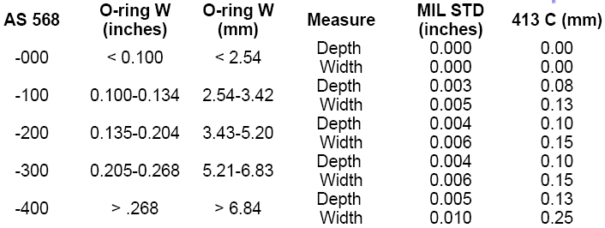
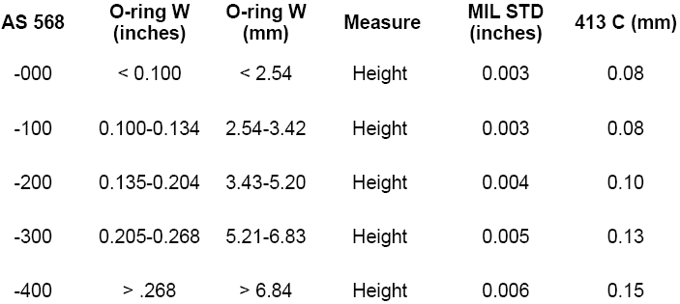

NON-FILL FOREIGN MATRIAL

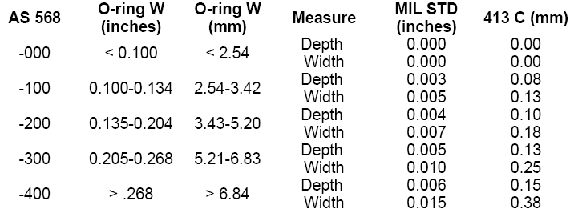
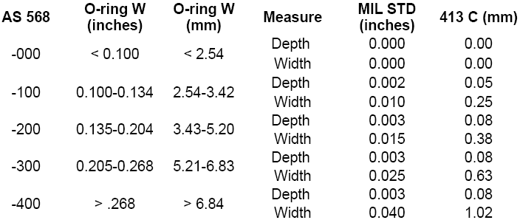

MOLD DEPOSIT INDENTATIONS FLOW MARKS
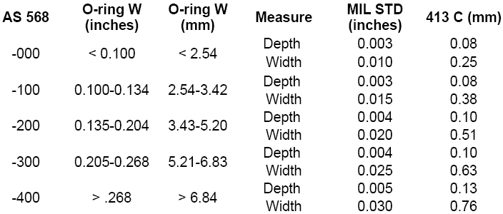
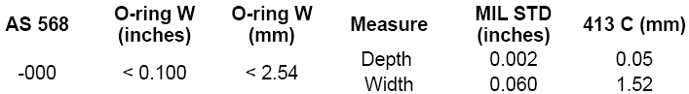

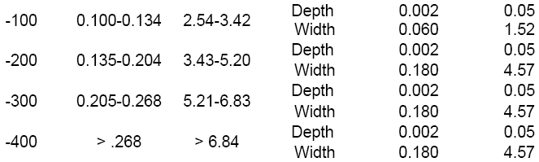

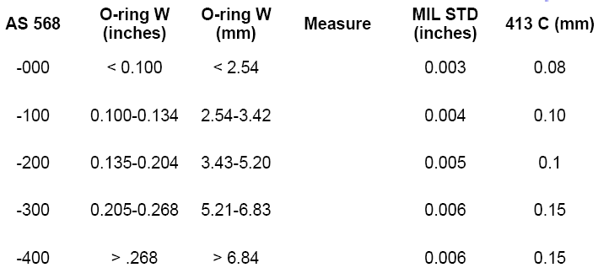
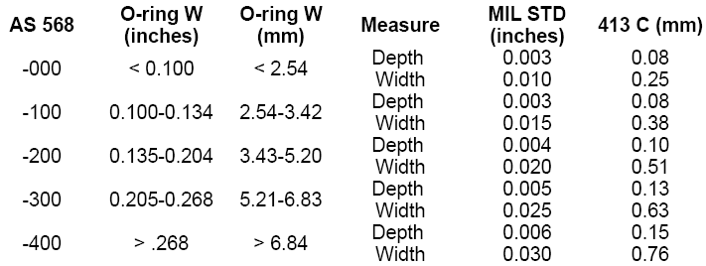
PARTING LINE INDENTATION OFF-REGISTER/MISMATCH

